Question Name : Weird Programmer

Flag : vishwaCTF{1T_1S_W31RD_N0T_T0_B3_W31RD}

Question Description:

I bet my friend who is a terrible poet and a really weird programmer that i can solve any encryption he makes in less than 3 tries but i may have underestimated him.

Can you help me win this bet?

attachment : poem.txt , weird programmer.txt

Poem.txt contents :

When you have broken the glass

and stepped into the eighth circle of hell,

you will find yourself under the pollux's spell

and after that you will be able to tell,

All's well that end's well

weird programmer.txt contents

{M[m(_o)O!"'&BA@?>~<543Wxwvutsrqponmlkjihgfe#zyx}|{zyrwp6WVUTSRQglejihgfe^$#DCBA@?>=<RW

VUTMRQJIm0/.-,+*)('&%$#"!~}|{zyxwvutsrqponmlkjihgfedcba`_^]\[ZYuWmrqpinmlkjc

)gf_d]#DCBA@?UZYXWPUTSRKoONGLKDh+*)('&%$@?8=<5:9810Tut210/.-,+k#Ghgfedcba`_^

]\[ZYXWmlkjonmlkjib(fHdcb[!_X]VzZSRvVOsMLQJONMFEiIHAFE>bB;:?87[|{zyxwvutsrqp

onmlk)i'&%$#"!~}v<]\[ZYXWVUTSRQPONMLKJIHGFEDCBA@?>=<;:9876543210/.-,+*)('=BA

:?>=<;:92V05.3,10)Mnmlkjihgfedcba`_^]\[ZYXWVUTSRQPONMLKJIHGFEDCBA@?>=<;:9876

543210/.-,+*)('&%$#"!~}|{zyxwvutsrqponmlkjihgfedcba`_^]\[ZYXWVUTSRQPONMLKJIH

GFEDCBA@?>=<;:9876543210/.-,+*)('&%$#"!~}|{zyxwvutsrqponmlkjihgfedcba`_^]\[Z

YXWVUTSRQPONMLKJIHGFEDCBA@?>=<;:9876543210/.-,+*)('&%$#"!~}|{zyxwvutsrqponml

kjihgfedcba`_^]\[ZYXWVUTSRQPONMLKJIHGFEDCBA@?>=<;:9876543210/.-,+*)('&%$#"!~

}|{zyxwvutsrqponmlkjihgfedcba`_^]\[ZYXWVUTSRQPONMLKJIHGFEDCBA@?>=<;:98765432

10/.-,+*)('&%$#"!~}|{zyxwvutsrqponmlkjihgfedcba`_^]\[ZYXWVUTSRQPONMLKJIHGFED

CBA@?>=<;:9876543210/.-,+*)('&%$#"!~}|{zyxwvutsrqponmlkjihgfedcba`_^]\[ZYXWV

UTSRQPONMLKJIHGFEDCBA@?>=<;:9876543210/.-,+*)('&%$#"!~}|{zyxwvutsrqponmlkjih

gfedcba`_^]\[ZYXWVUTSRQPONMLKJIHGFEDCBA@?>=<;:9876543210/.-,+*)('&%$#"!~}|{z

yxwvutsrqponmlkjihgfedcba`_^]\[ZYXWVUTSRQPONMLKJIHGFEDCBA@?>=<;:9876543210/.

-,+*)('&%$#"!~}|{zyxwvutsrqponmlkjihgfedcba`_^]\[ZYXWVUTSRQPONMLKJIHGFEDCBA@

?>=<;:9876543210/.-,+*)('&%$#"!~}|{zyxwvutsrqponmlkjihgfedcba`_^]\[ZYXWVUTSR

QPONMLKJIHGFEDCBA@?>=<;:9876543210/.-,+*)('&%$#"!~}|{zyxwvutsrqponmlkjihgfed

cba`_^]\[ZYXWVUTSRQPONMLKJIHGFEDCBA@?>=<;:9876543210/.-,+*)('&%$#"!~}|{zyxwv

utsrqponmlkjihgfedcba`_^]\[ZYXWVUTSRQPONMLKJIHGFEDCBA@?>=<;:9876543210/.-,+*

)('&%$#"!~}|{zyxwvutsrqponmlkjihgfedcba`_^]\[ZYXWVUTSRQPONMLKJIHGFEDCBA@?>=<

;:9876543210/.-,+*)('&%$#"!~}|{zyxwvutsrqponmlkjihgfedcba`_^]\[ZYXWVUTSRQPON

MLKJIHGFEDCBA@?>=<;:9876543210/.-,+*)('&%$#"!~}|{zyxwvutsrqponmlkjihgfedcba`

_^]\[ZYXWVUTSRQPONMLKJIHGFEDCBA@?[ZSXWVUTSRQPONMFjJCHA@d>CBA@?8\}|{zyxwvutsr

qponmlkji!&%$#"!~w|u;yxqputsrk1oQmle+iha'_dcb[Z~A@?>=<;:9876543210/.-,+*)('=

<A@?>=<543W7654t210)Mnmlkjihgfedcba`_^]\[ZYXWVUTSRQPONMLKJIHGFEDCBA@?>=<;:98

76543210/.-,+*)('&%$#"!~}|{zyxwvutsrqponmlkjihgfedcba`_^]\[ZYXWVUTSRQPONMLKJ

IHGFEDCBA@?>=<;:9876543210/.-,+*)('&%$#"!~}|{zyxwvutsrqponmlkjihgfedcba`_^]\

[ZYXWVUTSRQPONMLKJIHGFEDCBA@?>=<;:9876543210/.-,+*)('&%$#"!~}|{zyxwvutsrqpon

mlkjihgfedcba`_^]\[ZYXWVUTSRQPONMLKJIHGFEDCBA@?>=<;:9876543210/.-,+*)('&%$#"

!~}|{zyxwvutsrqponmlkjihgfedcba`_^]\[ZYXWVUTSRQPONMLKJIHGFEDCBA@?>=<;:987654

3210/.-,+*)('&%$#"!~}|{zyxwvutsrqponmlkjihgfedcba`_^]\[ZYXWVUTSRQPONMLKJIHGF

EDCBA@?>=<;:9876543210/.-,+*)('&%$#"!~}|{zyxwvutsrqponmlkjihgfedcba`_^]\[ZYX

WVUTSRQPONMLKJIHGFEDCBA@?>=<;:9876543210/.-,+*)('&%$#"!~}|{zyxwvutsrqponmlkj

ihgfedcba`_^]\[ZYXWVUTSRQPONMLKJIHGFEDCBA@?>=<;:9876543210/.-,+*)('&%$#"!~}|

{zyxwvutsrqponmlkjihgfedcba`_^]\[ZYXWVUTSRQPONMLKJIHGFEDCBA@?>=<;:9876543210

/.-,+*)('&%$#"!~}|{zyxwvutsrqponmlkjihgfedcba`_^]\[ZYXWVUTSRQPONMLKJIHGFEDCB

A@?>=<;:9876543210/.-,+*)('&%$#"!~}|{zyxwvutsrqponmlkjihgfedcba`_^]\[ZYXWVUT

SRQPONMLKJIHGFEDCBA@?>=<;:9876543210/.-,+*)('&%$#"!~}|{zyxwvutsrqponmlkjihgf

edcba`_^]\[ZYXWVUTSRQPONMLKJIHGFEDCBA@?>=<;:9876543210/.-,+*)('&%$#"!~}|{zyx

wvutsrqponmlkjihgfedcba`_^]\[ZYXWVUTSRQPONMLKJIHGFEDCBA@?>=<;:9876543210/.-,

+*)('&%$#"!~}|{zyxwvutsrqponmlkjihgfedcba`_^]\[ZYXWVUTSRQPONMLKJIHGFEDCBA@?>

=<;:9876543210/.-,+*)('&%$#"!~}|{zyxwvutsrqponmlkjihgfedcba`_^]\[ZYXWVUTSRQP

ONMLKJIHGFEDCBA@?>=<;:9876543210/.-,+*)('&%$#"!~}|{zyxwvutsrqponmlkjihgfedcb

a`_^]\[ZYXWVUTSRQPONMLKJIHGFEDCBA@?[ZSXWVUTSRQPONMFjJCg*)('&%$#"!~}|{zyxwvut

srq/.-,+k)"'&}|B"!~`|u;\[ZYXWVUTSRQPONMLKgfe^cba`Y^]Vz=<;:9876543210/.-,+*)(

'&%$#"!~}|{zyxwvutsrqponmlkjihgf|#"y~}|{zyxwp6WVUTSRQmlkjibg`e^$Ea`Y}]\[Z<XW

POs6543210/.-,+*)('&%$:?8=6;:9870Tu-2+*NMnmlkjih&%$#"!~}|u;\[ZYXWVUTSRQPONML

KJIHdcba`Y^]V[TxXWVUTMRQJnHl/.-,+*)('&%$#"!~}|{3816543210)Mnm+*#(!&%$#z@x}v<

tyr8YXWVUTSRQPONMLKJIHGFEa`_^]V[ZSXQuUTSRQ3INGkKJIHG@?c&%$#"!~}|{zyxwvutsr0/

.-,+*)(h&}C#"bx>|{tyrqvun4rqjonmle+LKJIHGFEDCBA@?>=<;:9876543210/.-,+*)('&%$

#"!~}|{zyxwvutsrqponmlkjihgfedcba`|{zyxwvunslk1Rnmlkjiha'HGFEDCBA@?>=<;:9876

543210/.-,+*)('&%$#"!~}|{zyxwvutsrqpo-,l*)('~%|#"y?`_^]\[ZYXWVUTSRQPONMLKJIH

GcEa`Y^]V[TSRv9876543210/.-,+*)('=B;@?>=<;:3W7w543,Pqponml$#(!~%$#"!x>_{zyxq

7XWVUTSingledihgf_%c\aZ~^]?UZYXWPtTMLp3INGk.-,+*)E'=B;:?>=<5Yz876543,Pqponml

k)('&%$#"!x>_^]yxwvutsrk1RQPONMLKgfedcba`YXW{[ZYXWPUTMqQJImMFKJIHAe('=B;@?>=

<;4XWV0543210)M-&+*)"Fgfedcba`_^]\[ZYXWVrqSinglkjiha'HGFEDCBA@?>=<;:98765432

10/.-,+*)('&%$#"!~}|{zyxwvutsrqponmlkjihgfedcba`_^]\[ZYutmrkponmledc)afe^$E[

Z_^]VzTYRWVONrLQPONGLKDh+*)('&<A@?>=<;:92VC"(_o)o.?]}

Detailed Solution :

Hints to identify from the poem

1. broken the glass

2. eight circle of hell

3. Pollux’s spell

Step 1 : Run Glass code

On searching on google you find that Glass is an esolang for which you can find a lot of information online. Given below is the wikipedia page for Glass Language :

<https://esolangs.org/wiki/Glass>

If you see in the examples section you will see the code for the **“Hello World” program** in glass

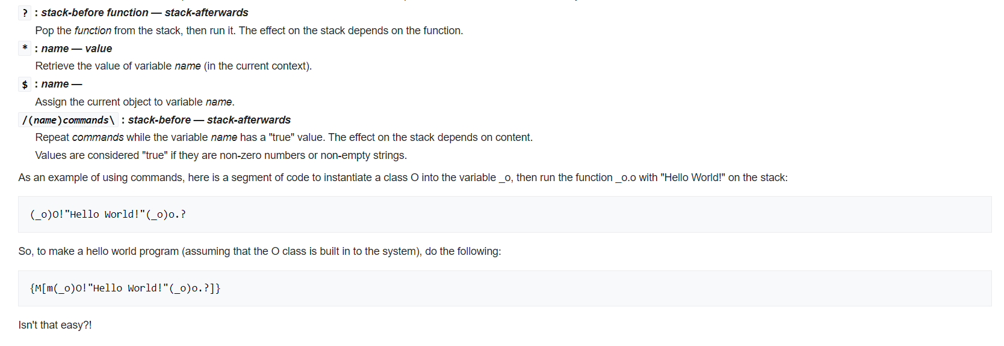

on observing this you will see that just the words Hello World have been replaced with another ciphertext . Just remove this syntax for glass and you have successfully broken the glass.

you get the ciphertext as :

Ciphertext = '&BA@?>~<543Wxwvutsrqponmlkjihgfe#zyx}|{zyrwp6WVUTSRQglejihgfe^$#DCBA@?>=<RW

VUTMRQJIm0/.-,+*)('&%$#"!~}|{zyxwvutsrqponmlkjihgfedcba`_^]\[ZYuWmrqpinmlkjc

)gf_d]#DCBA@?UZYXWPUTSRKoONGLKDh+*)('&%$@?8=<5:9810Tut210/.-,+k#Ghgfedcba`_^

]\[ZYXWmlkjonmlkjib(fHdcb[!_X]VzZSRvVOsMLQJONMFEiIHAFE>bB;:?87[|{zyxwvutsrqp

onmlk)i'&%$#"!~}v<]\[ZYXWVUTSRQPONMLKJIHGFEDCBA@?>=<;:9876543210/.-,+*)('=BA

:?>=<;:92V05.3,10)Mnmlkjihgfedcba`_^]\[ZYXWVUTSRQPONMLKJIHGFEDCBA@?>=<;:9876

543210/.-,+*)('&%$#"!~}|{zyxwvutsrqponmlkjihgfedcba`_^]\[ZYXWVUTSRQPONMLKJIH

GFEDCBA@?>=<;:9876543210/.-,+*)('&%$#"!~}|{zyxwvutsrqponmlkjihgfedcba`_^]\[Z

YXWVUTSRQPONMLKJIHGFEDCBA@?>=<;:9876543210/.-,+*)('&%$#"!~}|{zyxwvutsrqponml

kjihgfedcba`_^]\[ZYXWVUTSRQPONMLKJIHGFEDCBA@?>=<;:9876543210/.-,+*)('&%$#"!~

}|{zyxwvutsrqponmlkjihgfedcba`_^]\[ZYXWVUTSRQPONMLKJIHGFEDCBA@?>=<;:98765432

10/.-,+*)('&%$#"!~}|{zyxwvutsrqponmlkjihgfedcba`_^]\[ZYXWVUTSRQPONMLKJIHGFED

CBA@?>=<;:9876543210/.-,+*)('&%$#"!~}|{zyxwvutsrqponmlkjihgfedcba`_^]\[ZYXWV

UTSRQPONMLKJIHGFEDCBA@?>=<;:9876543210/.-,+*)('&%$#"!~}|{zyxwvutsrqponmlkjih

gfedcba`_^]\[ZYXWVUTSRQPONMLKJIHGFEDCBA@?>=<;:9876543210/.-,+*)('&%$#"!~}|{z

yxwvutsrqponmlkjihgfedcba`_^]\[ZYXWVUTSRQPONMLKJIHGFEDCBA@?>=<;:9876543210/.

-,+*)('&%$#"!~}|{zyxwvutsrqponmlkjihgfedcba`_^]\[ZYXWVUTSRQPONMLKJIHGFEDCBA@

?>=<;:9876543210/.-,+*)('&%$#"!~}|{zyxwvutsrqponmlkjihgfedcba`_^]\[ZYXWVUTSR

QPONMLKJIHGFEDCBA@?>=<;:9876543210/.-,+*)('&%$#"!~}|{zyxwvutsrqponmlkjihgfed

cba`_^]\[ZYXWVUTSRQPONMLKJIHGFEDCBA@?>=<;:9876543210/.-,+*)('&%$#"!~}|{zyxwv

utsrqponmlkjihgfedcba`_^]\[ZYXWVUTSRQPONMLKJIHGFEDCBA@?>=<;:9876543210/.-,+*

)('&%$#"!~}|{zyxwvutsrqponmlkjihgfedcba`_^]\[ZYXWVUTSRQPONMLKJIHGFEDCBA@?>=<

;:9876543210/.-,+*)('&%$#"!~}|{zyxwvutsrqponmlkjihgfedcba`_^]\[ZYXWVUTSRQPON

MLKJIHGFEDCBA@?>=<;:9876543210/.-,+*)('&%$#"!~}|{zyxwvutsrqponmlkjihgfedcba`

_^]\[ZYXWVUTSRQPONMLKJIHGFEDCBA@?[ZSXWVUTSRQPONMFjJCHA@d>CBA@?8\}|{zyxwvutsr

qponmlkji!&%$#"!~w|u;yxqputsrk1oQmle+iha'_dcb[Z~A@?>=<;:9876543210/.-,+*)('=

<A@?>=<543W7654t210)Mnmlkjihgfedcba`_^]\[ZYXWVUTSRQPONMLKJIHGFEDCBA@?>=<;:98

76543210/.-,+*)('&%$#"!~}|{zyxwvutsrqponmlkjihgfedcba`_^]\[ZYXWVUTSRQPONMLKJ

IHGFEDCBA@?>=<;:9876543210/.-,+*)('&%$#"!~}|{zyxwvutsrqponmlkjihgfedcba`_^]\

[ZYXWVUTSRQPONMLKJIHGFEDCBA@?>=<;:9876543210/.-,+*)('&%$#"!~}|{zyxwvutsrqpon

mlkjihgfedcba`_^]\[ZYXWVUTSRQPONMLKJIHGFEDCBA@?>=<;:9876543210/.-,+*)('&%$#"

!~}|{zyxwvutsrqponmlkjihgfedcba`_^]\[ZYXWVUTSRQPONMLKJIHGFEDCBA@?>=<;:987654

3210/.-,+*)('&%$#"!~}|{zyxwvutsrqponmlkjihgfedcba`_^]\[ZYXWVUTSRQPONMLKJIHGF

EDCBA@?>=<;:9876543210/.-,+*)('&%$#"!~}|{zyxwvutsrqponmlkjihgfedcba`_^]\[ZYX

WVUTSRQPONMLKJIHGFEDCBA@?>=<;:9876543210/.-,+*)('&%$#"!~}|{zyxwvutsrqponmlkj

ihgfedcba`_^]\[ZYXWVUTSRQPONMLKJIHGFEDCBA@?>=<;:9876543210/.-,+*)('&%$#"!~}|

{zyxwvutsrqponmlkjihgfedcba`_^]\[ZYXWVUTSRQPONMLKJIHGFEDCBA@?>=<;:9876543210

/.-,+*)('&%$#"!~}|{zyxwvutsrqponmlkjihgfedcba`_^]\[ZYXWVUTSRQPONMLKJIHGFEDCB

A@?>=<;:9876543210/.-,+*)('&%$#"!~}|{zyxwvutsrqponmlkjihgfedcba`_^]\[ZYXWVUT

SRQPONMLKJIHGFEDCBA@?>=<;:9876543210/.-,+*)('&%$#"!~}|{zyxwvutsrqponmlkjihgf

edcba`_^]\[ZYXWVUTSRQPONMLKJIHGFEDCBA@?>=<;:9876543210/.-,+*)('&%$#"!~}|{zyx

wvutsrqponmlkjihgfedcba`_^]\[ZYXWVUTSRQPONMLKJIHGFEDCBA@?>=<;:9876543210/.-,

+*)('&%$#"!~}|{zyxwvutsrqponmlkjihgfedcba`_^]\[ZYXWVUTSRQPONMLKJIHGFEDCBA@?>

=<;:9876543210/.-,+*)('&%$#"!~}|{zyxwvutsrqponmlkjihgfedcba`_^]\[ZYXWVUTSRQP

ONMLKJIHGFEDCBA@?>=<;:9876543210/.-,+*)('&%$#"!~}|{zyxwvutsrqponmlkjihgfedcb

a`_^]\[ZYXWVUTSRQPONMLKJIHGFEDCBA@?[ZSXWVUTSRQPONMFjJCg*)('&%$#"!~}|{zyxwvut

srq/.-,+k)"'&}|B"!~`|u;\[ZYXWVUTSRQPONMLKgfe^cba`Y^]Vz=<;:9876543210/.-,+*)(

'&%$#"!~}|{zyxwvutsrqponmlkjihgf|#"y~}|{zyxwp6WVUTSRQmlkjibg`e^$Ea`Y}]\[Z<XW

POs6543210/.-,+*)('&%$:?8=6;:9870Tu-2+*NMnmlkjih&%$#"!~}|u;\[ZYXWVUTSRQPONML

KJIHdcba`Y^]V[TxXWVUTMRQJnHl/.-,+*)('&%$#"!~}|{3816543210)Mnm+*#(!&%$#z@x}v<

tyr8YXWVUTSRQPONMLKJIHGFEa`_^]V[ZSXQuUTSRQ3INGkKJIHG@?c&%$#"!~}|{zyxwvutsr0/

.-,+*)(h&}C#"bx>|{tyrqvun4rqjonmle+LKJIHGFEDCBA@?>=<;:9876543210/.-,+*)('&%$

#"!~}|{zyxwvutsrqponmlkjihgfedcba`|{zyxwvunslk1Rnmlkjiha'HGFEDCBA@?>=<;:9876

543210/.-,+*)('&%$#"!~}|{zyxwvutsrqpo-,l*)('~%|#"y?`_^]\[ZYXWVUTSRQPONMLKJIH

GcEa`Y^]V[TSRv9876543210/.-,+*)('=B;@?>=<;:3W7w543,Pqponml$#(!~%$#"!x>_{zyxq

7XWVUTSingledihgf_%c\aZ~^]?UZYXWPtTMLp3INGk.-,+*)E'=B;:?>=<5Yz876543,Pqponml

k)('&%$#"!x>_^]yxwvutsrk1RQPONMLKgfedcba`YXW{[ZYXWPUTMqQJImMFKJIHAe('=B;@?>=

<;4XWV0543210)M-&+*)"Fgfedcba`_^]\[ZYXWVrqSinglkjiha'HGFEDCBA@?>=<;:98765432

10/.-,+*)('&%$#"!~}|{zyxwvutsrqponmlkjihgfedcba`_^]\[ZYutmrkponmledc)afe^$E[

Z_^]VzTYRWVONrLQPONGLKDh+*)('&<A@?>=<;:92VC

Step 2 :

Now if you google Eight Circle as hell you get the answer as Malbolge

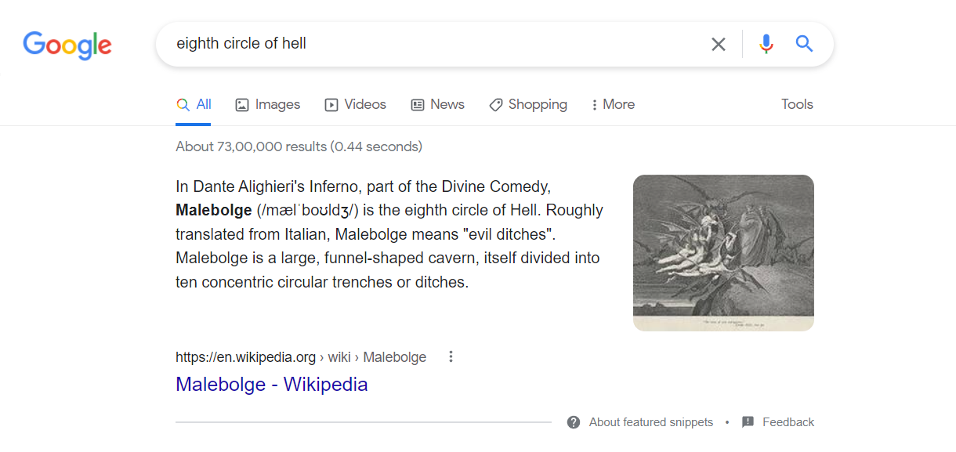

now if you run the malbolge in any malbolge interpreter you get the following cipher text:

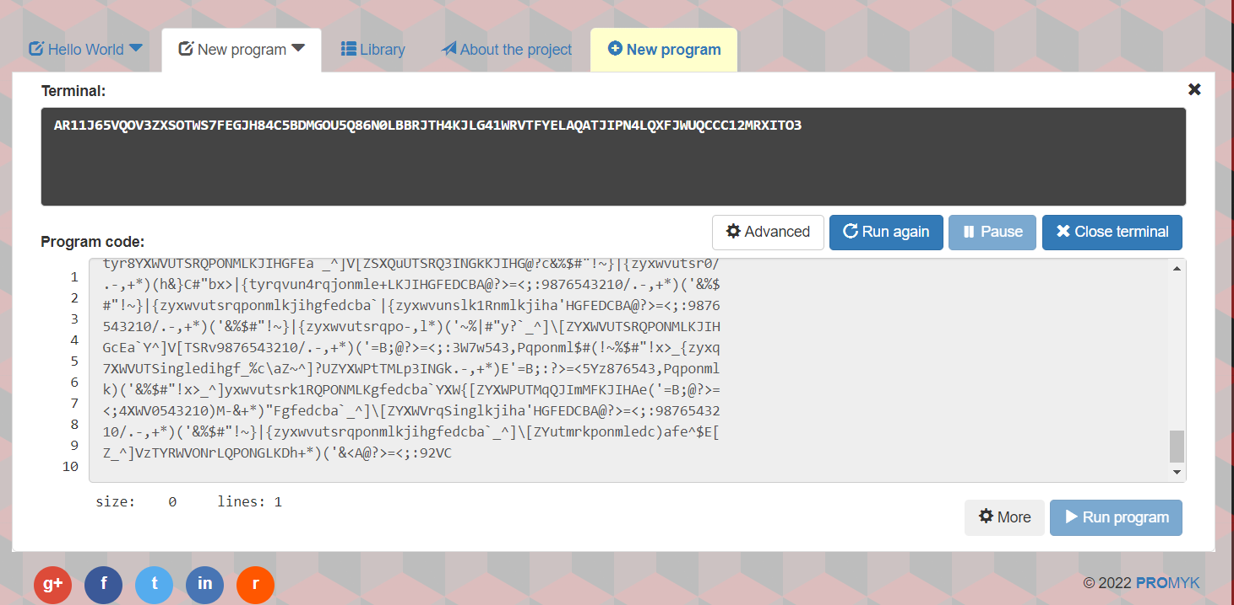

ciphertext = AR11J65VQOV3ZXSOTWS7FEGJH84C5BDMGOU5Q86N0LBBRJTH4KJLG41WRVTFYELAQATJIPN4LQXFJWUQCCC12MRXITO3

Step 3 :

now pollux’s spell suggests that it is a pollux cipher decode it in any online decoder to get the original message as :

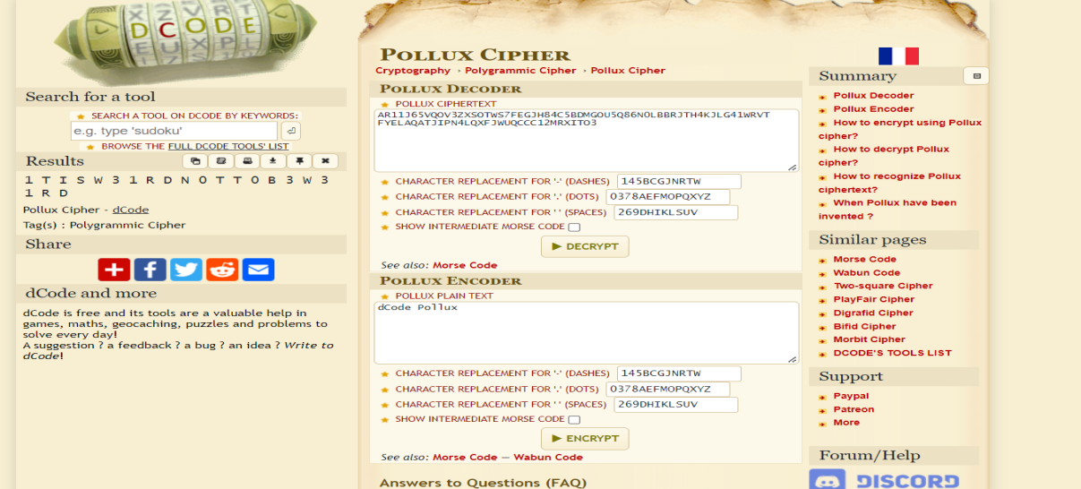

flag = 1T1SW31RDN0TT0B3W31RD

wrap it in flag format to get submission ready flag as :

Final flag : vishwaCTF{1T_1S_W31RD_N0T_T0_B3_W31RD}